

Enhancing Access to Justice through
People-Centred Justice in Italy
Diagnosis report
CONFIDENTIAL

Multi-country project
24IE07 | 24IT38 | 24MT03 | 24NL05
​Enhancing Access to Justice Through People-Centred Justice

Italy

1. Understanding people’s legal needs and justice problems

Introduction
Justice systems are at their strongest when they reflect the needs of the people they serve. Similar to patterns observed in other countries, in Italy justice problems often arise from ordinary interactions in people’s daily lives: at home, at work, and within their communities. Individuals confront challenges that affect not only their rights, but also their health, livelihoods, and relationships (WJP, 2024). These issues are not confined to courtrooms or legal offices; they emerge in interactions with public services, with their neighbours, in the workplace, and in efforts to access essential goods and services.
Legal needs surveys play a critical role in understanding how people experience justice in practice. By systematically capturing the types of justice problems people face, how frequently they occur, and how individuals seek to resolve them, such surveys provide an essential evidence base for people-centred justice reforms. They help move analysis beyond institutional processes and formal case data, shedding light on unmet legal needs, barriers to access, and the broader impacts of unresolved problems on people’s lives. As of the publication of this report, Italy does not have a regular, nationally institutionalised legal needs survey. As a result, available insights into people’s justice experiences rely largely on ad hoc or international data sources, underscoring the importance of leveraging existing survey evidence to inform policy discussions and future measurement efforts.
To identify the justice problems people face in their everyday lives, how they attempt to address these problems, and the pathways they follow in seeking resolution, this diagnosis uses the World Justice Project’s Eurovoices General Population Poll was conducted in Italy. The survey reached 3 844 people across the five NUTS-1 regions of the country (North-West, North-East, Centre, South, Islands), capturing people’s overall experiences as they navigated justice problems, sought information and advice, engaged with formal or informal mechanisms, and attempted to resolve their problems. Importantly, the data does not directly reflect the performance of individual courts or justice actors.
The survey was administered online between 1 March and 1 April 2024. As such the data reflect people’s experience prior to the implementation of several reforms adopted under Italy’s National Plan for Recovery and Resilience in the subsequent period. The findings therefore provide a baseline snapshot of legal needs and justice experiences against which the evolution and potential effects of ongoing and future reforms may be assessed. More information on the survey design, sampling strategy, and data collection process can be found in Annex.
Italy’s justice system builds on several important strengths, while also presenting areas where further progress could support a more people-centred approach. People’s experiences with justice system in Italy highlight how individuals encounter legal needs and justice problems in their everyday lives, including the types of issues involved, their prevalence, and the ways in which these problems tend to cluster and reinforce one another. They also point to the consequences that arise when legal needs are unmet or when problems remain unresolved, including the human, economic, and social impacts that can follow. Taken together, these patterns enable a holistic understanding of legal needs and justice problems in Italy, grounded in evidence of people’s perspective.

Encountering justice problems in Italy
Understanding how people in Italy experience justice problems requires examining not only how widespread these issues are, but also who is most affected, the nature of the problems encountered, and the extent to which they occur together. The findings suggest a justice system in which justice and administrative challenges are common, interlinked, and unevenly distributed across the population. These patterns suggest a combination of structural, socioeconomic, and demographic factors, all of which help explain why certain groups face greater difficulties in managing and resolving their justice problems.

Prevalence of non-trivial justice problems
Justice problems are a common part of everyday life. In Italy, more than half of the people (58%) experienced at least one non-trivial justice problem in the two-year reference period captured by the survey. A problem is considered serious or “non-trivial” when individuals rate its seriousness at four or above on a ten-point scale, signalling that the issue had a genuine and substantive impact on their lives. This high prevalence places Italy above the average of the EU Member States (49%), suggesting that people face non-trivial justice problems more often than their counterparts in other EU countries (WJP, 2024).
The reported justice problems arise across a variety of areas: people most often face issues related to public services (31%), consumer protection (27%), money and debt (23%), problems linked to their local communities (22%), to their family (13%), land (13%), and employment (12%) (see Figure 1.1). Within these broad areas, people frequently encounter specific issues, including difficulties in obtaining care from public health providers, conflicts with neighbours, unsatisfactory or incomplete professionals services, and problems in paying debts (WJP, 2024). The widespread nature of these issues highlights the need of justice systems and public institutions to be equipped to engage with a broad spectrum of legal needs and justice problems, many of which emerge from ordinary interactions in everyday life.
Figure 1.1. Prevalence of non-trivial justice problems in Italy, by problem category
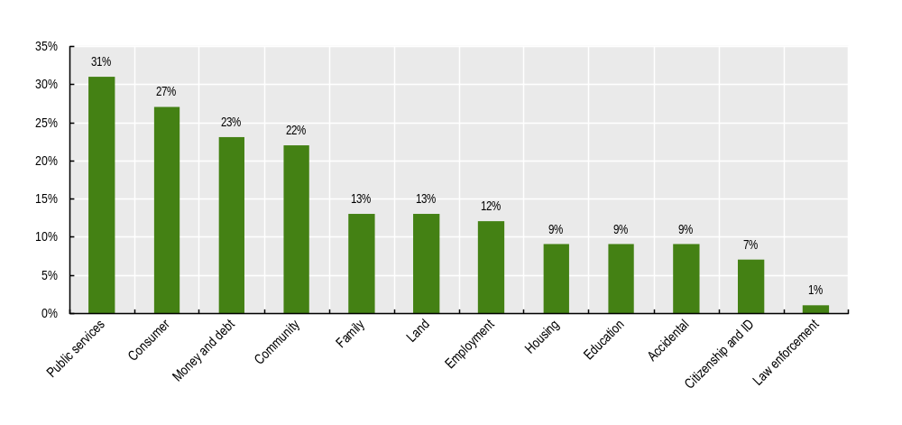
Note: Percentage of respondents who experienced at least one non-trivial justice problem in the past two years by problem category.
Source: (WJP, 2024)
Although justice problems are widespread and affect all parts of society, there are disparities across sociodemographic groups. Acknowledging these disparities contributes to understanding the nature of legal needs and for designing people-centred justice responses. First, women experience non-trivial justice problems at higher rates than men (60% compared to 56%). Prevalence is also significantly higher among young adults aged 25 – 34 (67%) than in other age groups, as well as among individuals in financially constrained situations (72%) compared with those in more secure situations (53%) (WJP, 2024) (see Figure 1.2). Taken together, the higher incidence of non-trivial justice problems within these groups suggests broader socioeconomic inequalities that both intensify existing difficulties and place additional pressures on the well-being of those affected.
Figure 1.2. Prevalence of non-trivial justice problems in Italy
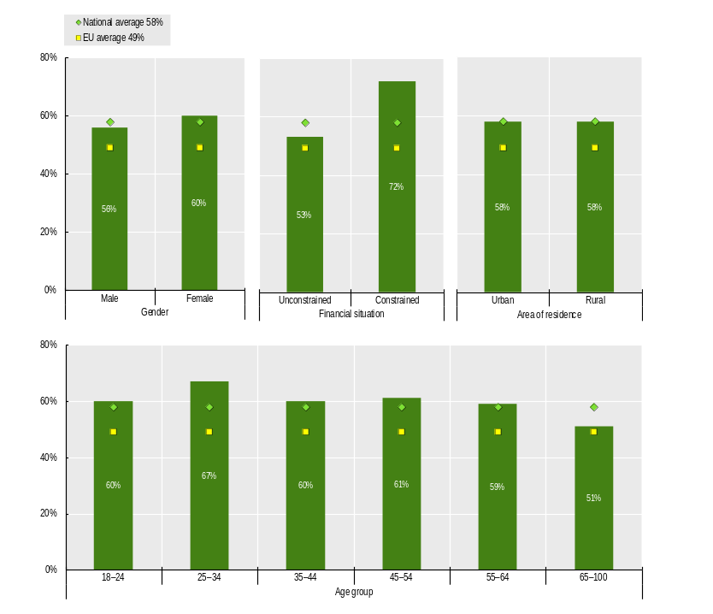
Note: Percentage of respondents who experienced at least one non-trivial justice problem in the past two years, meaning a problem of self-reported seriousness of 4 or more on a scale of 0 to 10.
Source: (WJP, 2024)

Co-occurrence of non-trivial justice problems
People who encounter non-trivial justice problemsoften face several problems concurrently. On average, people with at least one non-trivial justice problem deal with around 4.1 issues simultaneously over the two-year reference period. The burden tends to be heavier for younger adults: those aged 18 – 24 and 25 – 34 typically face more than five concurrent problems, whereas people 55 and over encounter roughly three. Financial circumstances also play a major role. Individuals living in households under financial strain experience about 5.7 concurrent problems, the highest level recorded, in contrast to 3.4 among those without such pressures (see Figure 1.3). This high degree of co-occurrence suggests that justice problems tend to accumulate, with one problem often reinforcing or triggering others (WJP, 2024).
Figure 1.3. Co-occurrence of non-trivial justice problems in Italy
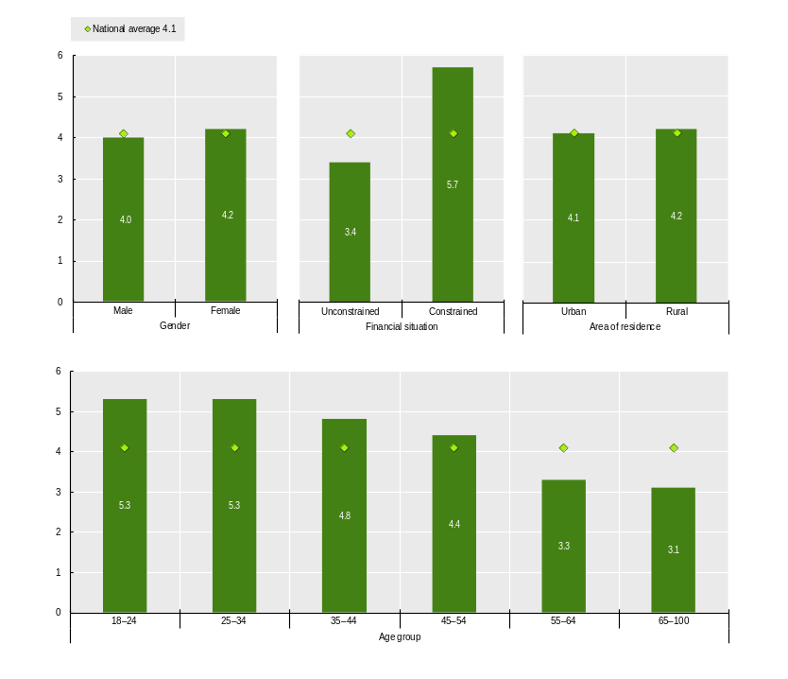
Note: Number of non-trivial justice problems experienced concurrently by a single person in the past two years (occurring during the same period).
Source: (WJP, 2024)

Steps in people’s justice pathways
Understanding how people address their problems is essential to assessing the accessibility, fairness, and effectiveness of justice systems. Individuals rarely experience justice as a single event. Instead, they navigate a pathway of interactions and experiences: from seeking information, to obtaining assistance, to engaging formal or informal dispute resolution mechanisms, and ultimately reaching an outcome. Throughout this pathway, personal circumstances, the nature of the problem, and the broader institutional environment shape people’s experiences and opportunities.

Access to information and advice
Access to information and advice can be a first step when attempting to resolve everyday problems. In Italy, slightly more than half of those who encountered a serious justice issue in the previous two years report being able to identify a reliable source of information and advice about resolving their problem. The proportion stands at 58%, which places Italy a few points below the EU average (61%) (WJP, 2024).
In Italy, access to information and advice differs across sociodemographic and experiential group. Men more frequently state that they know where to obtain trustworthy information than women (61% compared to 55%). Similarly, people without financial constraints are more likely to access information (60%) than those who struggle to cover basic expenses (55%). The type of problem also influences access to information. Individuals dealing with consumer-related issues tend to have better access (64%), whereas those facing employment-related problems (53%) or difficulties with public services (53%) are much less likely to know where to turn (see Figure 1.4). These gaps are compounded when multiple issues arise simultaneously. The number of co-occurring justice problems also affects access to information and advice. People dealing with a single issue are able to obtain help more often than those facing five or more problems (63% compared to 52%) (WJP, 2024).
Despite these relatively high levels of access among those directly experiencing justice problems, public trust in the system remains limited. In fact, while more than half of people who face a serious issue are able to find guidance, only 34% in the broader population believes that someone in Italy would know where to turn for information and advice if confronted with a legal difficulty (WJP, 2024). This gap between personal experience and public perception suggests that the justice system may function reasonably well for those who actively engage with it. These findings point to the importance of a people-centred approach, ensuring that legal information and support services are not only available but also accessible and clearly communicated. Tailoring services to the diverse needs, vulnerabilities, and knowledge levels of different population groups can help make access to information and advice more equitable.
Figure 1.4. Access to information and advice in Italy
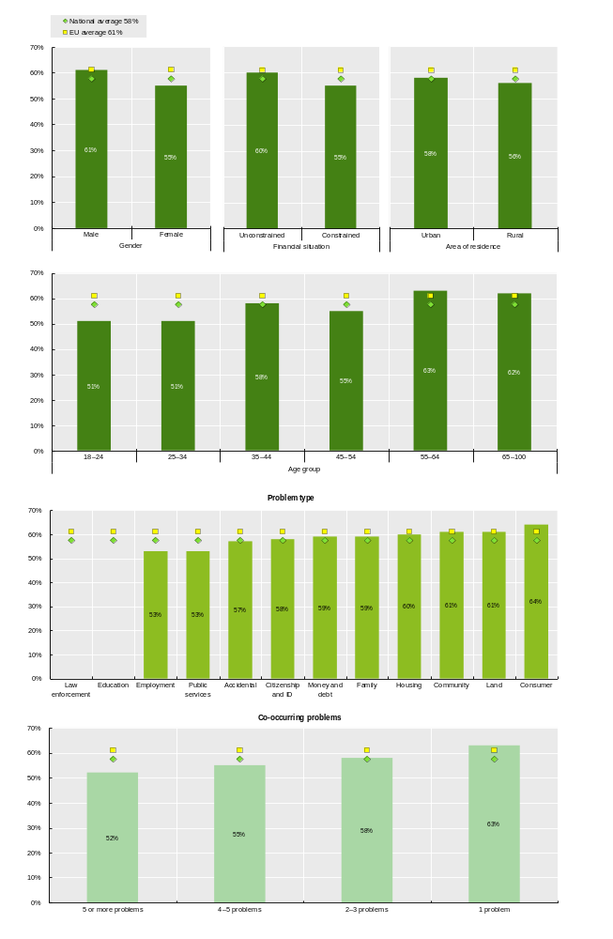
Note: Percentage of respondents who had access to appropriate information and advice out of those who experienced a non-trivial justice problem in the past two years.
Source: (WJP, 2024)

Access to assistance and representation
Access to assistance and representation is a central component of how people navigate the justice system. Of those who experienced a non-trivial justice problem, only around 40% attempt to seek advice or representation, while the remaining majority does not reach out to anyone. Among the individuals who do not seek support, some consider professional help unnecessary (20%), yet the larger portion indicate that they do need assistance but are unable to obtain it (37%). Meanwhile, among those who do seek advice, most consult an appropriate advisor (33%), including a lawyer, a professional advisor, an advice service, a government legal aid office, a court or government body, the police, a health or welfare professional, a trade union or employer, a civil society organisation, a religious or community leader, or a friend or relative with a legal background. Instead, the remaining minority tend to rely on a non-professional advisor (e.g. a friend or relative without a legal background, or an unknown person), raising the risk of receiving ineffective or inaccurate information. Combining these pathways, just over half of people in Italy who faced a non-trivial justice problem eventually receive proper assistance and representation (53%), a figure broadly in line with the EU average (54%) (WJP, 2024) (see Figure 1.5).
Disparities appear along gender and economic lines. Men are more likely than women to obtain appropriate help (57% compared to 50%), and those without financial constraints are better than those facing economic hardship (54% compared to 50%). Additionally, the nature of the justice problem also matters. Individuals dealing with issues related to land tenure report higher access to suitable assistance and representation (66%), while people confronting public service (47%), consumer protection (52%), or employment problems (55%) experience lower access rates. In particular, analysis of the relationship between selected factors and the likelihood of accessing assistance and representation shows that men, individuals in employment, those facing concurrent problems, residents of Southern Italy, and people encountering family-, housing- or land-related issues are more likely to access assistance and representation (WJP, 2024).
As regards the sources of assistance, most people who manage to reach appropriate support turn to lawyers or professional advisers (70%). Others seek help from friends or relatives with legal background (17%), defined as individuals who have attended law school or work for an organisation that provides legal advice. Fewer than half of people seeking assistance (48%) rely on a single advisor, while 27% consult two or more (WJP, 2024).
Several factors continue to hinder people’s ability to obtain assistance. The financial cost of legal assistance is the most common deterrent (24%), followed by difficulties in determining whom to contact for advice (16%) and a lack of awareness that assistance can be sought at all (14%). Fear of negative consequences, although less common, is also present (3%). In addition to these practical difficulties, many people perceive legal assistance as largely inaccessible: while 53% of people are actually able to access appropriate assistance, only 28% of the general population believe that people in Italy would have access to affordable legal help if they needed it (WJP, 2024). Although this perception cannot be directly compared with individual experiences reported in the survey, the justice system appears to be perceived as not always easy to access or afford. Lower visibility of available services, inconsistent quality, or broader mistrust in institutions may contribute to this perception of limited accessibility.
Figure 1.5. Pathways to accessing appropriate assistance and representation in Italy
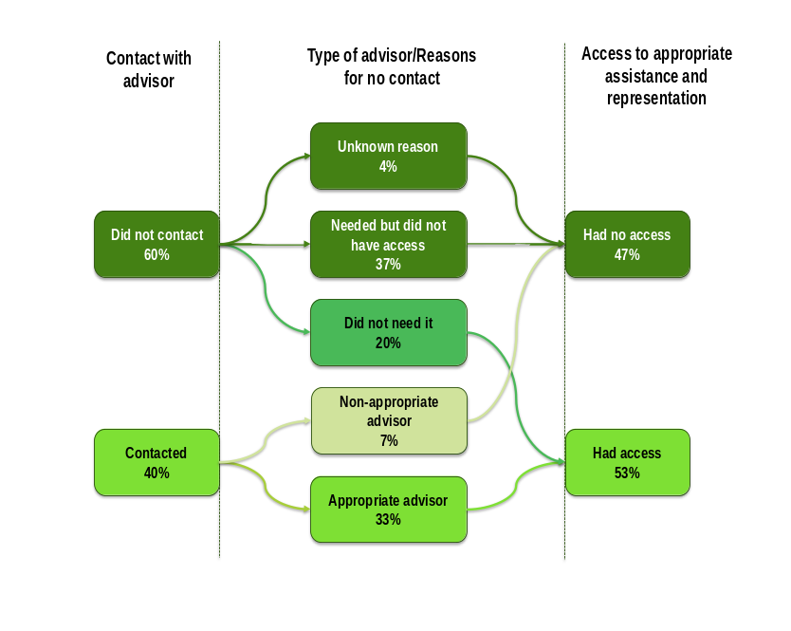
Note: Percentage of respondents who experienced at least one non-trivial justice problem. Percentages shown in the figure sum up to 100% at each stage (i.e., vertically).
Source: (WJP, 2024)

Access to dispute resolution mechanisms
Another essential element of justice pathways regards access to dispute resolution mechanisms, including filing a claim in court or with a tribunal, reaching out to the police or another prosecution authority, contacting a government office or designated agency, seeking guidance from a religious authority or community leader, using third-party mediation, engaging a conciliation or arbitration tribunal, or pursuing a formal complaints or appeals process. In Italy, a relatively small share of people who experienced a non-trivial justice problem turns to a third-party individual or organisation to intervene, mediate, or adjudicate (19%). Instead, 81% does not pursue such assistance. Of those, a large portion does not feel the need to turn to a dispute resolution mechanism (54%), while others need help but cannot overcome the procedural and informational constraints that stand in the way (33%). Among them, several people have the expectation that the process would be lengthy or burdened by bureaucracy (38%), while others are unsure about the steps to take or the appropriate structures to contact (23%). Additional deterrents include fear of retaliation (17%), practical issues related to cost, distance, or scheduling (12%) and lack of trust in the authorities (9%) (WJP, 2024).
Ultimately, among people who need a dispute resolution mechanism, only 42% succeed in accessing one, pointing to a significant shortfall in access to justice (see Figure 1.6). This percentage is slightly higher than the EU average of 40%, suggesting that limited access to dispute resolution mechanisms is a widespread challenge in the EU. Disparities are again apparent. People living in rural areas have significantly lower access than residents of urban centres (33% and 42%, respectively). Additionally, people dealing with five or more simultaneous problems are more likely to reach a dispute resolution mechanism (52%) than those facing only one issue (36%).
A analysis suggests that individuals aged 25 – 34 are less likely to reach a dispute resolution mechanism in Italy. In contrast, the probability of accessing such mechanisms increases for those residing in the South or the Islands, for people dealing with several justice problems at the same time, and for those encountering issues related to employment, family matters, housing, or land (WJP, 2024).
Courts and tribunals are the most frequently approached dispute resolution mechanisms (72%), followed by government offices (53%), third-party mediators (50%), complaints or appeal bodies (47%), and the police (41%). Overlapping use of several institutions is common, with 59% of people contacting three or more institutions, indicating that people rarely rely on a single pathway (WJP, 2024).
Figure 1.6. Pathways to accessing dispute resolution mechanisms (DRM) in Italy
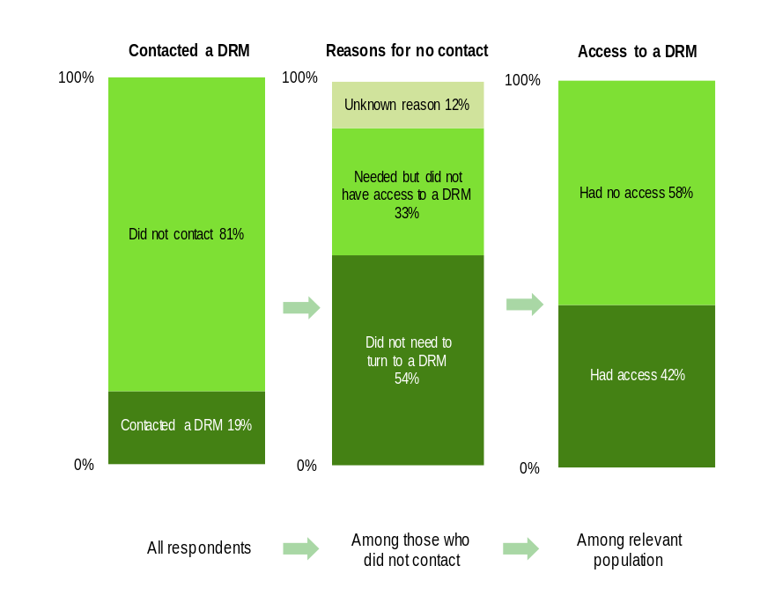
Note: Percentage of respondents who reported a non-trivial justice problem. Percentages shown in the figure sum up to 100% at each stage (i.e. vertically).
Source: (WJP, 2024)

Timeliness, fairness and costliness of the resolution process
For those who are “done” with their non-trivial justice problem, either because it was fully resolved, or because the process was discontinued, the resolution process is generally considered timely. A substantial majority (84%), resolve their issue within a year, placing Italy above the EU average (74%). However, timeliness varies according to financial and experiential factors. Individuals without economic hardship have a slightly faster resolution experience than those with a constrained financial situation (86% compared to 80%), and those dealing with a single justice problem are far more likely to have their case resolved in under a year than individuals with five or more overlapping issues (89% compared to 72%).
Despite the efficiency suggested by the relatively high rate of issues resolved within a year, perceptions of delay remain widespread in Italy. A majority of people describe the process as slow (53%), with this sentiment particularly common among people aged 25 – 34 (61%), rural residents (60%) and people in financially constrained situations (55%) (WJP, 2024).
Perceptions of fairness of the dispute resolution process are similarly divided. Just over half of people who report their non-trivial justice problem as concluded consider the process they had undergone to be fair, regardless of the outcome (52%), a figure just below the EU average (54%). Differences across demographic groups are marked, with women reporting lower perceptions of fairness than men (49% compared to 55%), and rural residents rating the system as fair less often than urban residents (46% compared to 52%). Additionally, perception of fairness is higher among people experiencing only one problem (59%), compared to those experiencing five or more concurrent problems (39%), and among individuals in financially unconstrained situation (52%) compared to those facing financial constraints (50%) (WJP, 2024).
Cost considerations also affect people’s justice journeys. Most people are able to afford the costs related to the resolution process or do not incur any expenses (80%), although this proportion remain slightly below the EU average (82%). When asked to assess the costliness of the process, 28% describe it as expensive. The perception of high costs rise substantially among people managing five or more problems (44%), among people aged 18 – 24 (36%), and among people in a financially constrained situation (35%) (WJP, 2024).

Outcome of the resolution process
Turning to outcomes, 68% of people who are done dealing with their problem, either by fully resolving it, or by abandoning the process with no further action, state that the problem is fully resolved. This result, although positive, does not reach the EU level (72%). There are some differences based on gender: 69% of men resolved their problem, compared to 67% of women. Additionally, the gap between individuals dealing with a single problem and those handling multiple overlapping problems is substantial, with resolution rates falling from 71% for people facing only one issue to 55% among those burdened by more than five co-occurring problems (WJP, 2024) (see Figure 1.7).
A clear majority of people (63%) is satisfied with the resolution or with how the situation is unfolding. Satisfaction is considerably higher among those whose outcomes were favourable (85%) and far lower among those whose issues remained unresolved or ended unfavourably (31%) (WJP, 2024).
Figure 1.7. Outcome of people’s justice problems in Italy
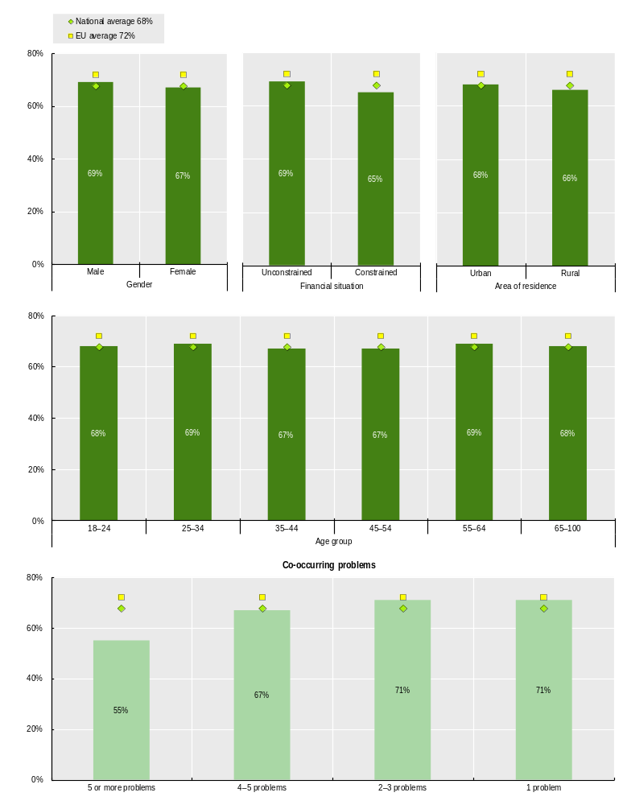
Note: Percentage of respondents who described the resolution process as “done with” and whose justice problem was solved, out of those who experienced a non-trivial justice problem in the previous two years and whose problem resolution process had concluded.
Source: (WJP, 2024)

Experiencing the consequences of unmet legal needs and unresolved justice problems
A core component of assessing people’s justice experiences is understanding their unresolved justice problems. This concept refers to individuals whose justice problems remain unresolved because their rights cannot be upheld, enforced, or realised through fair and effective mechanisms. In practice, the unresolved justice problems span several groups whose experiences reflect different ways in which justice systems fail to meet basic needs.
One group consists of people who are unable to find solutions for routine civil, administrative, or criminal problems. A second group includes people who lack the legal tools and protections that allow them to participate fully in economic, social, and civic life. This encompasses individuals without essential documents or legal arrangements, such as identity papers, recognised tenure over their home or land, or formal employment contracts. The third group covers those who live in environments marked by severe injustice. This includes, for example, people who are stateless, victims of modern slavery, or individuals living in contexts where insecurity and institutional fragility undermine the most fundamental rights.
Taken together, these categories exemplify how unresolved justice problems arise across a spectrum. They also illustrate how structural factors such as financial costs, limited legal literacy and capability, weak institutions, and systemic exclusion can prevent people from accessing the protections and remedies to which they are entitled. This reflects not only failures in resolving individual problems but also deeper inequalities that place the greatest burdens on those with the least capacity to navigate legal systems (WJP, 2019). For the purposes of this report, the analysis focuses on individuals who encounter routine civil or administrative problems and are unable to resolve them fully.
In Italy, nearly half of people facing non-trivial justice problems report not receiving adequate access to information and advice, appropriate assistance or representation, effective resolution of their cases, or satisfactory outcomes along their justice journey (50%). It is worth noting that the survey was administered in the first months of 2024, prior to the implementation of certain NRRP reforms. The incidence is particularly high among younger individuals, with people aged 18 – 24 experiencing the highest rates of unmet legal needs at 57%. Sociodemographic and situational factors also correlate with an increased likelihood of not receiving access to information and advice, appropriate assistance or representation, effective resolution of cases, or satisfactory outcomes in the justice journey. Unemployment and the presence of concurrent justice problems further elevate the risk of unmet needs. Moreover, a majority of people in financially constrained situations does not receive access to information and advice, appropriate assistance or representation, effective resolution of their cases, or satisfactory outcomes in their justice journey (54%), compared to 48% of people in unconstrained financial situations. Women have unresolved justice problems more often than men (51% compared to 48%), and people living in rural areas face this issue more often than those residing in urban areas (52% compared to 49%) (see Figure 1.8).
In terms of specific problems among people who do not receive access to information and advice, appropriate assistance or representation, effective resolution of their cases, or satisfactory outcomes in their justice journey, the most frequently unmet need is access to information, reported by 65% of people, followed closely by access to advice and representation, which affects 60% of people. Many individuals experience multiple problems simultaneously; for example, one in five people with unresolved justice problems reports lacking both information and adequate advice or representation (WJP, 2024). This suggests that civil and administrative justice challenges are rarely isolated and often compound one another.
The consequences of these unmet legal needs extend beyond unresolved problems, impacting negatively people’s lives and producing tangible hardships across health, economic, and social domains. Over half of people who reported at least one non-trivial justice problem experience some form of hardship as a direct consequence of their unmet legal needs (52%). Health-related effects are particularly prevalent, with 37% reporting stress-related illness, physical injury, or deterioration in overall well-being. Economic repercussions are also substantial: 23% of people tend to experience income loss, employment disruption, financial strain, or the need to relocate. Social relationships are affected as well, with 17% reporting negative impacts on family life, and a smaller proportion reporting substance abuse as a coping mechanism (4%) (WJP, 2024). These findings suggest that not receiving access to information and advice, appropriate assistance or representation, effective resolution of cases, or satisfactory outcomes in the justice journey is not merely an issue of legal inefficiency: it has significant effects on individuals’ capacity to participate fully in society and the economy, maintain livelihoods, and safeguard personal and family well-being.
Figure 1.8. Unmet legal needs and unresolved justice problems in Italy
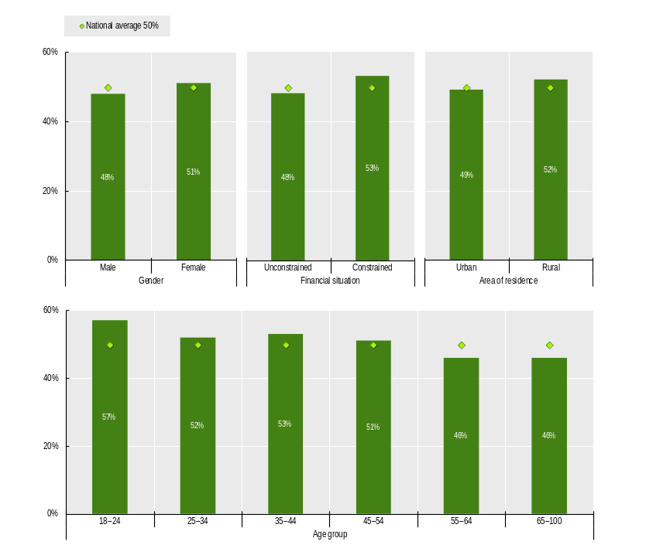
Note: Percentage of respondents with serious a justice problem that face more than one of the following unmet needs: (1) access to information and advice, (2) access to appropriate assistance and representation, (3) timeliness, affordability, and fairness of the resolution process, and (4) full resolution of the problem. While a person may confront multiple injustices, they are considered here if at least one-third of their civil and administrative legal needs are unmet.
Source: (WJP, 2024)

2. The state of people-centred justice

Designing and delivering people-centred justice services
The second pillar of the Recommendation focuses on designing and delivering legal and justice services with people at the centre. This begins with identifying people's legal needs, preferences, and capabilities through data, engagement, and evidence on what works. Services must be accessible, tailored, and delivered in plain language. People-centred design ensures services are preventive, responsive, able to address recurring problems systematically, and continuously improved based on feedback. The overall aim is to provide appropriate, affordable, and effective services that lead to fair processes and outcomes (OECD, Forthcoming).
In Italy, efforts to design and deliver justice services that respond to people’s needs and experiences are ongoing, though they vary in scope and degree of systematisation. While yet comprehensive national framework to be established, the design and delivery of justice services build on a range of initiatives and practices related to legal capability, access to information and support, geographic accessibility, and the use of data and user feedback.

Taking into account people’s legal capability and ability to resolve justice problems
The third policy indicator, focused on service design, examines whether the justice sector designs a continuum of services taking into account capabilities and problem resolution. It looks in particular at whether justice service design is informed by an assessment of legal capability of the people experiencing justice problems, as well as evidence on effective problem resolution. It also considers whether services are appropriately distributed geographically, so that they are reachable, including with public transportation (OECD, Forthcoming).
In Italy, 74% of people who experienced a serious legal problem report that they understood, or came to understand, their legal rights and responsibilities at some stage while dealing with the issue. This suggests a relatively high overall level of legal awareness. At the same time, it implies that around one quarter of individuals confront justice problems without a clear understanding of their legal position, which may limit their ability to make informed decisions and navigate available options effectively. Differences across socio-economic groups are notable, particularly in relation to financial circumstances. Among people living in financially constrained situations, 68% report understanding their rights, compared to 78% of those in unconstrained situations. This gap points to the weight of economic disadvantage in shaping access to information, advice and support networks that underpin legal capability and empowerment. Narrowing these disparities across socio-demographic groups may therefore be an important lever for strengthening equitable access to justice (WJP, 2024).
There are also challenges related to access to expert support. In Italy, only half of people receive all the professional assistance they feel they need, indicating considerable scope for improving access to expert support. Levels of satisfaction vary across age groups and by gender. Among people aged over 65, 81% receive all the help they want, compared to 67% of those aged 18 – 24, suggesting greater difficulties faced by younger people in identifying, affording, or engaging with appropriate experts. Gender differences are also evident, with 47% of women reporting full satisfaction with the help received, compared to 54% of men. In addition, people’s perceptions of the origins of their justice problems highlight structural and economic challenges. Bureaucratic factors are the most frequently cited cause, reported by 23% of individuals with non-trivial justice problems, followed by economic causes at 21%. The prominence of bureaucratic factors suggests that administrative complexity, procedural obstacles, and institutional inefficiencies are widely perceived as key drivers of legal disputes (WJP, 2024).
Complementing this picture, data collected by ISTAT cover several dimensions linked to legal capability, including individuals’ awareness of procedural costs, their knowledge of ADR mechanisms, decision-making around whether to pursue legal claims, and perceptions of justice processes and outcomes. Survey findings indicate, for instance, that only 28% of individuals involved in a civil case were aware of the expected costs at the outset, with pronounced differences by gender, age, education level, and region. Awareness of at least one form of ADR is reported by 44% of the population, with higher levels among those with university or post-university education and lower levels among younger people under 35 and those over 65 (ISTAT, 2023). At the same time, Italy’s data landscape does not yet provide a comprehensive or explicit assessment of legal capability. Instead, existing surveys capture selected aspects of people’s interactions with the justice system, without integrating them into a dedicated legal capability framework. Moreover, these surveys are not standalone instruments, and offer limited in-depth coverage of groups in vulnerable situations, such as migrants, persons with disabilities and children.
While a fully consistent, system-wide approach to designing justice services based on an understanding of people’s legal capability has yet to be stablished, efforts have emerged mainly through ad hoc and locally driven initiatives, such as the redesign of procedures affecting vulnerable groups and the establishment of the Proximity Offices (“Uffici di Prossimità”) intended to improve access to information and support (Ministry of Justice of Italy, 2024). Another relevant practice is the collection of judicial and statistical data by the Gender and Domestic Violence Observatory (“Osservatorio Violenza di Genere e Domestica”), which supports monitoring of gender- and domestic-violence cases across judicial offices. This data helps identify critical issues in judicial processes, informs the dissemination of effective organisational practices, and supports the design of technical and regulatory improvements. Insights derived from the Observatory also contribute to training for judicial staff, helping translate lessons learned into more effective service delivery for victims.
While these initiatives reflect growing attention to integrating people’s needs and capabilities into the design and delivery of justice services, further strengthening the consistency of their implementation and the use of systematic, evidence-based assessments could enhance their contribution to a more coherent and effective people-centred justice. Further progress could be supported by institutionalising a comprehensive legal capability framework at the national level, with regular and systematic data collection, and by more consistently using such data to inform the design and delivery of justice services across justice institutions and service providers.

Delivering and improving justice services based on people’s experiences
The fourth policy indicator, focused on service delivery, measures whether the justice sector delivers a continuum of appropriate, proportionate, affordable, effective and responsive services. It looks at whether services effectively address legal needs and justice problems, in particular the most common justice problems. It assesses whether justice services ask for feedback about people’s experiences with the service. It also assesses mechanisms for gathering people’s views on fairness, process and outcomes, and whether services evolve based on this evidence (OECD, Forthcoming).
Justice services in Italy encompass a number of initiatives aimed at responding to people’s needs. At the same time, there are opportunities to further strengthen the use of systematic assessments of people’s legal needs and capabilities in the design and continuous improvement of services. In particular, expanding the availability of comprehensive and regularly collected data on the types of justice problems experience, the pathways people follow to address them, and the outcomes achieved could further enrich the evidence base supporting the development of people-centred justice services. At present, the design and improvement of services draw on a range of sector-specific and ad hoc sources of information that inform certain aspects of service delivery, with the potential to be applied more broadly and consistently across the justice system.
With respect to geographic accessibility, Italy has implemented some initiatives to bring justice services closer to people. In particular, the Proximity Offices (“Uffici di Prossimità”), launched in 2019, aim to relocate selected justice-related activities from central judicial offices to local access points closer to where people live, often in collaboration with municipalities and other territorial actors. The initiative, now operational in 16 regions, seeks to reduce practical difficulties linked to distance, mobility and territorial disparities and reflects an effort to improve physical access to justice services. As of 2024, 85 Proximity Offices have been activated nationwide, with 239 agreements signed for the opening of additional ones. They registered 7481 visits, 16,881 interactions handled by office staff, and 7 047 services delivered (Ministry of Justice of Italy, 2024).
In addition, draft bill C. 2646 concerning the revision of the judicial map is currently under consideration before the lower Chamber of the Italian Parliament. This proposal seeks to adjust the territorial organisation of courts and related offices on the basis of objective criteria such as population distribution, territorial characteristics, case flows, and the performance of existing offices, with the aim of improving both efficiency and geographic accessibility (Parliament of Italy, 2025).
To respond to people and businesses’ needs for justice services that are easier to navigate, efforts have been undertaken within the broader agenda for public administration and administrative simplification. This agenda aims to reduce procedural timeframes and regulatory burdens, and providing legal certainty for people and businesses (Ministry for Public Administration of Italy, 2020). These efforts have been reinforced under Italy’s NRRP, which identifies administrative simplification as a cross-cutting priority (Ministry for Public Administration of Italy, 2025).
In addition, notaries have played an important role in improving the delivery of justice services by drawing on their day-to-day interactions with the public to identify recurring justice problems and promote initiatives and legislative proposals aimed at simplifying procedures and preventing disputes. These include reforms to facilitate acts involving minors and incapacitated persons (Fabiani & Piccolo, 2023), instruments aimed at facilitating business succession (National Council of Notaries, Confindustria, 2012), initiatives to reduce litigation risks in housing transactions involving donated property (Parliament of Italy, 2025), and measures to ensure the effective expression of legal will for persons with severe disabilities (National Council of Notaries, 2023). To illustrate, the National Council of Notaries (“Consiglio Nazionale del Notariato”) has collaborated with the Italian Multiple Sclerosis Association (“Associazione Italiana Sclerosi Multipla”, AISM) to support research and practical applications of technologies such as eye-tracking devices to enable people with disabilities to express legal will and execute public acts (AISM, 2025). These examples illustrate improvements in service delivery by addressing accessibility gaps in justice services.
With regard to addressing the most common justice problems people face, existing justice services primarily provide support through sector-specific information tools. Notaries, for instance, have an important front-line role in translating legal requirements into practical guidance for people in Italy. This is reflected in targeted initiatives, notably guides developed by the National Council of Notaries (“Consiglio Nazionale del Notariato”) on issues such as property, family matters, inheritance, and contracts, which correspond to areas where justice problems frequently arise (National Council of Notaries, 2025). These efforts are commendable, and further progress could be achieved by strengthening the evidence-based approach underpinning service design. In this respect, legal needs surveys, studies on legal capabilities, or other people-centred research tools could provide a robust foundation for assessing whether existing services adequately address the most prevalent justice problems, respond effectively to people’s needs, and help identify remaining gaps and opportunities for improvement.
Information on the resolution of justice problems is available in Italy primarily through administrative and sector-specific data. In particular, Italy collects and reports data on the clearance rate and disposition time of civil and criminal proceedings, which provide insights into the efficiency with which justice proceedings are resolved (Ministry of Justice of Italy, 2025). In addition, official statistics and monitoring reports on ADR mechanisms, especially civil mediation, include data on successful resolution rates for cases that are referred to and concluded through these procedures (Ministry of Justice of Italy, 2025). While these sources provide valuable insights on outcomes of formal proceedings, further information on how justice problems are resolved outside courts or mediation could enrich the evidence base. This would support a comprehensive understanding of people’s ability to resolve their justice problems across the full range of situations they encounter. To support the design and improvement of justice services that respond to people’s needs and experiences, it would be beneficial to complement existing administrative data with comprehensive and periodic legal needs surveys or equivalent research methods that collect data on the resolution of justice problems, regardless of whether they result in formal proceedings.
The collection of feedback from users of justice services in Italy currently takes place mainly through localised and project-based initiatives. User satisfaction surveys have been conducted on an occasional basis in specific jurisdictions, such as the courts of Rome, Turin, and Catania, as well as through more recent local surveys linked to justice-related services, including police (Court of First Instance of Rome, 2015) (Ministry of Justice of Italy, 2011) (Municipality of Genoa, 2023). While these initiatives reflect growing attention to user experience and provide useful insights at the local level, they are yet isolated and project based. Further progress could be achieved by establishing regular and institutionalised surveys to collect feedback across justice services, with data systematically embedded to continuously inform improvements in service delivery.

Defined as problems of self-reported seriousness of 4 or more on a scale of 0 to 10, where 0 represents the least serious and 10 represents the most serious problem the respondent could ever face in their lifetime.
The survey was conducted between March 1 and April 1, 2024; therefore, the two‑year reference period covers March 2022 – March 2024.
A logistic regression is a statistical method used to examine the relationship between one or more characteristics (such as age, gender, income, or location) and the likelihood that a particular outcome occurs. In this report, logistic regression results are presented as average marginal effects, which show how the predicted probability of an outcome changes when a respondent belongs to one group rather than a reference group.

